Test Case: tc001_SPX_Dev5_Crear_Solicitud_Articulo_Almacen
Step 1 - Enter username and password and click to button Enter : Credentials Entered
Image file-name: QC_Testing-tc001_SPX_Dev5_Crear_Solicitud_Articulo_Almacen-1787939621108

Step 2 - Select to UEN and Access to Request for a New Inventory Item : UEN Correctly selected and Correct access
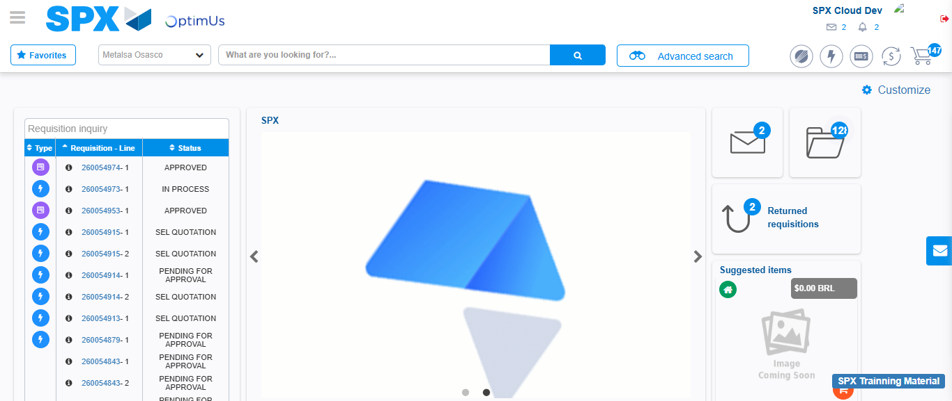Image file-name: QC_Testing-tc001_SPX_Dev5_Crear_Solicitud_Articulo_Almacen-1787939685556

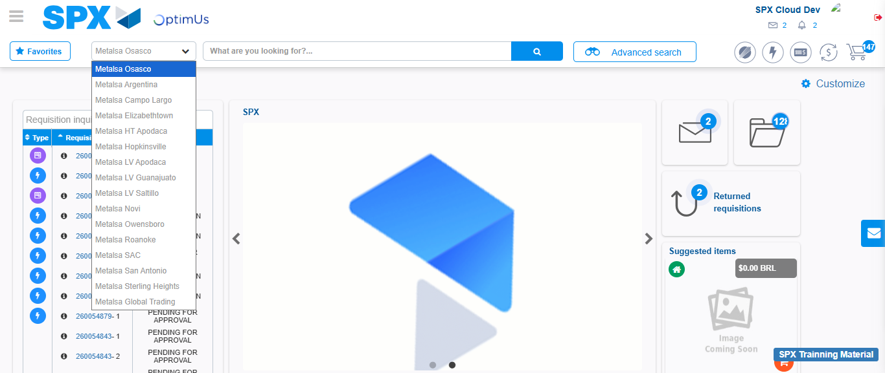Image file-name: QC_Testing-tc001_SPX_Dev5_Crear_Solicitud_Articulo_Almacen-1787939686157

Image file-name: QC_Testing-tc001_SPX_Dev5_Crear_Solicitud_Articulo_Almacen-1787939692875

Step 3 - Select options first section : Options seleted correctly
Image file-name: QC_Testing-tc001_SPX_Dev5_Crear_Solicitud_Articulo_Almacen-1787939693115

Image file-name: QC_Testing-tc001_SPX_Dev5_Crear_Solicitud_Articulo_Almacen-1787939693284

Step 4 - Select options at Screen: Options seleted correctly
Image file-name: QC_Testing-tc001_SPX_Dev5_Crear_Solicitud_Articulo_Almacen-1787939693115

Image file-name: QC_Testing-tc001_SPX_Dev5_Crear_Solicitud_Articulo_Almacen-1787939693284

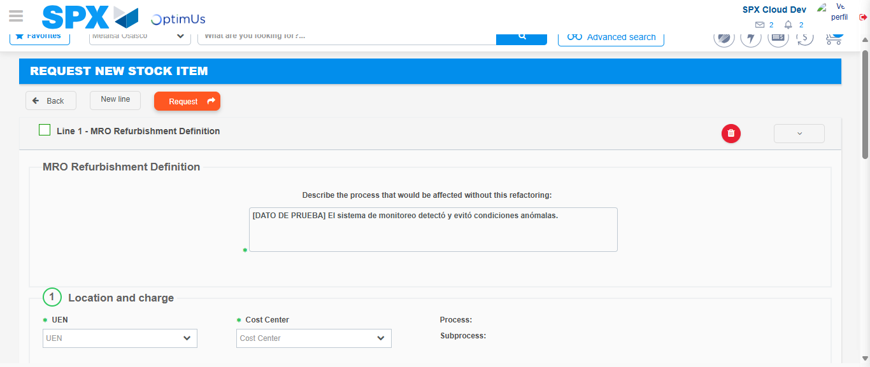Image file-name: QC_Testing-tc001_SPX_Dev5_Crear_Solicitud_Articulo_Almacen-1787939704389

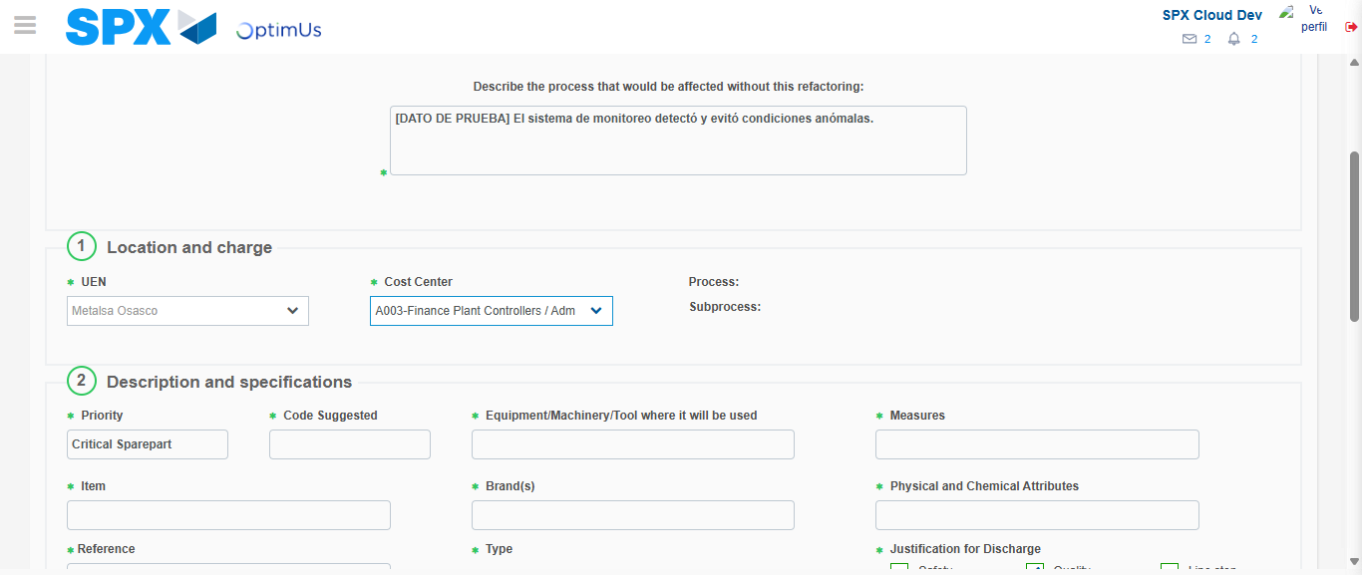Image file-name: QC_Testing-tc001_SPX_Dev5_Crear_Solicitud_Articulo_Almacen-1787939706968

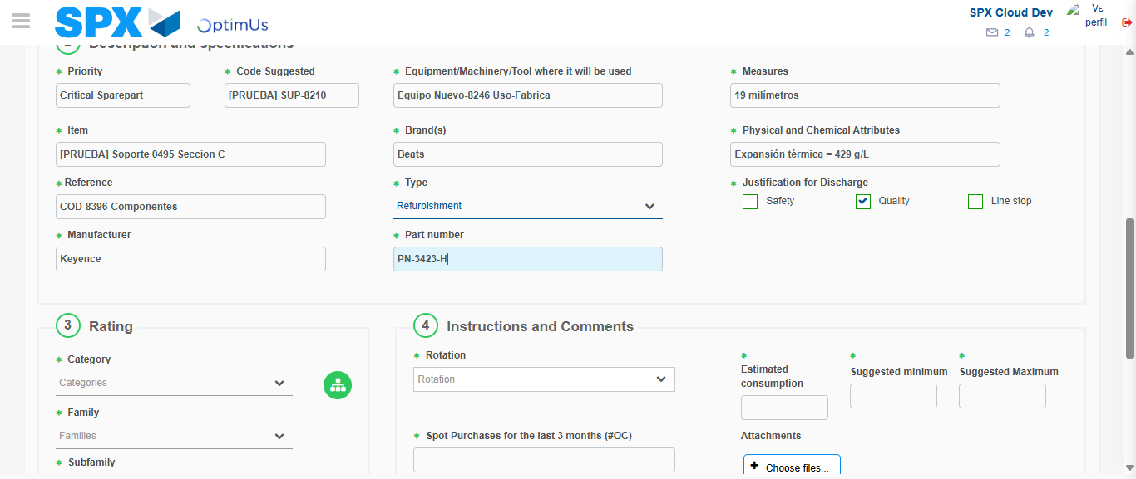Image file-name: QC_Testing-tc001_SPX_Dev5_Crear_Solicitud_Articulo_Almacen-1787939708221

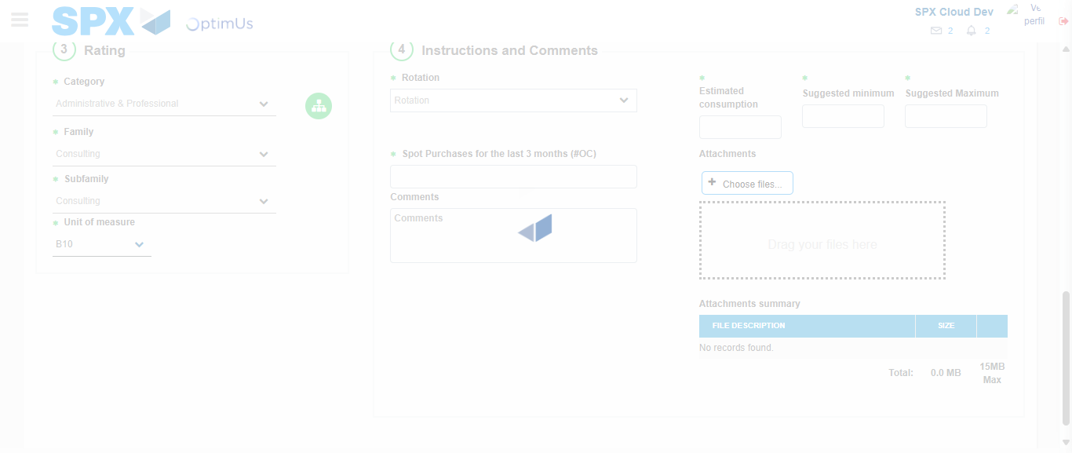Image file-name: QC_Testing-tc001_SPX_Dev5_Crear_Solicitud_Articulo_Almacen-1787939712481

Step 5 - Request New Item : Request Accepted
Image file-name: QC_Testing-tc001_SPX_Dev5_Crear_Solicitud_Articulo_Almacen-1787939685556

Image file-name: QC_Testing-tc001_SPX_Dev5_Crear_Solicitud_Articulo_Almacen-1787939686157

Image file-name: QC_Testing-tc001_SPX_Dev5_Crear_Solicitud_Articulo_Almacen-1787939692875

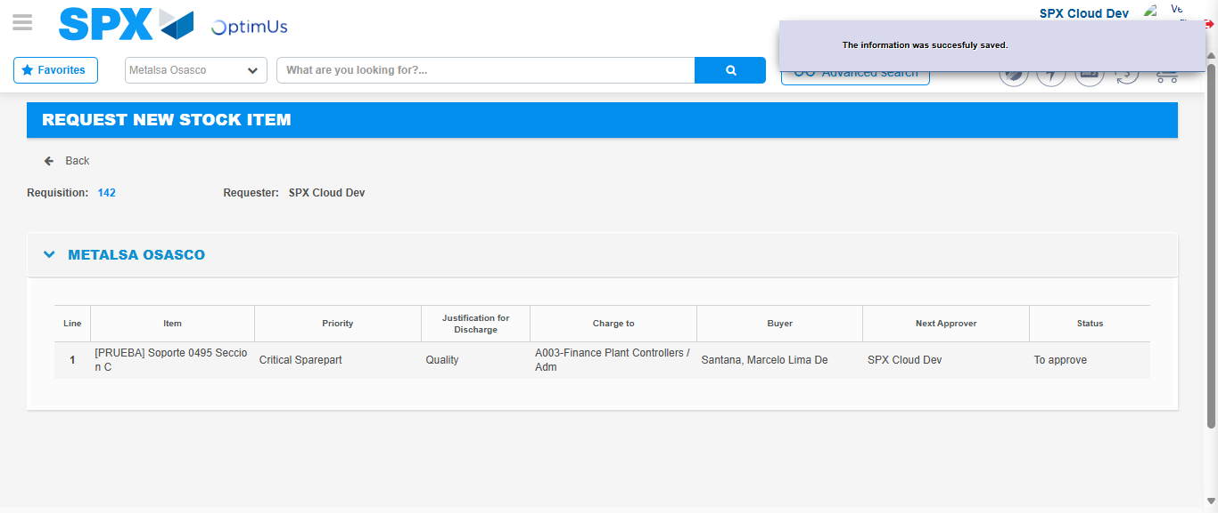Image file-name: QC_Testing-tc001_SPX_Dev5_Crear_Solicitud_Articulo_Almacen-1787939720574

Image file-name: QC_Testing-tc001_SPX_Dev5_Crear_Solicitud_Articulo_Almacen-1787939720748

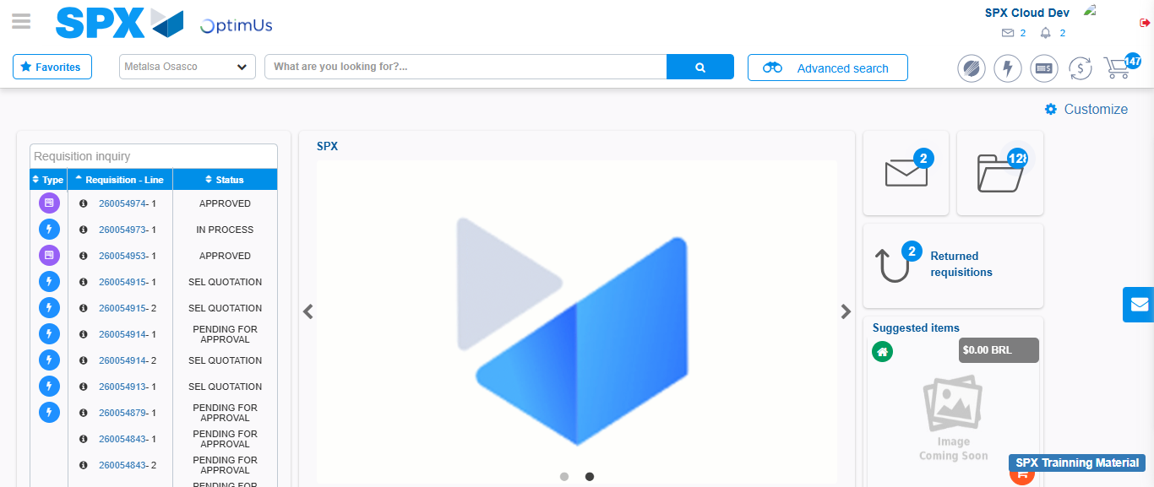Image file-name: QC_Testing-tc001_SPX_Dev5_Crear_Solicitud_Articulo_Almacen-1787939741986

Step 7 - Return to Main Page SPX : Return to Main Page SPX
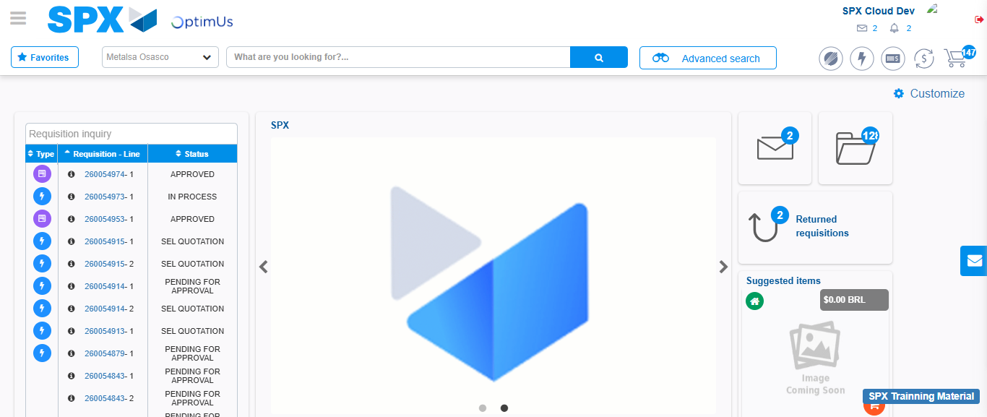Image file-name: QC_Testing-tc001_SPX_Dev5_Crear_Solicitud_Articulo_Almacen-1787939742319

